|  |  |
| --- | --- |
| **WC Logo.emf** | **Staff Report to the Weber County Commission**  *Weber County Planning Division* |
|  | |

****Synopsis****

****Application Information****

**Application Request: A request for approval of an ordinance to vacate** the 10-foot public utility easement, located along the north side of lot 2 of the Lake View Estates, 1282 N 7100 E, Eden. A public hearing for this request was held on November 30th, 2021.

**Agenda Date: Wednesday, December 14, 2021**

**Applicant:** Gerald Allred

**File Number:** UVL110121

****Property Information****

**Approximate Address:** 1350 N 7100 E, Eden

**Project Area:** 7.8 acres

**Zoning:** AV-3

**Existing Land Use:** Residential

**Proposed Land Use:** Residential

**Parcel ID:** 21-103-0004, 21-103-0003, 21-103-0002

**Township, Range, Section:** T6N, R2E, Section 06

****Adjacent Land Use****

**North:** Residential **South:** Residential

**East:** Residential **West:** Residential

****Staff Information****

**Report Presenter: Felix Lleverino**

[flleverino@co.weber.ut.us](mailto:flleverino@co.weber.ut.us)

**801-399-8767**

**Report Reviewer: SB**

Applicable Ordinances

* Title 101, Chapter 1, General Provisions, Section 7, Definitions
* Title 104, Chapter 2, Agricultural Zones
* Title 104, Zones, Chapter 28, Ogden Valley Sensitive Lands Overlay Districts
* Title 106, Subdivisions, Chapter 1-8 as applicable

Development History

This Subdivision was originally recorded in 2004 as Lake View Estates, a two-lot subdivision.

On November 1, 2021, Mr. Gerald Allred submitted an application for approval of an amended plat.

On November 30th, 2021 a public hearing was held to vacate the public utility easement from the north side of lot 2 of Lake View Estates. The request was approved unanimously.

On December 14th, 2021 the vacating ordinance was presented before County Commission as an administrative item for approval.

Background and Summary

The owner of lots 1 and 2 of Lake View Estates is requesting approval of an ordinance to vacate a public utility easement. The request to vacate was presented to the County Commission in a public hearing that was held on November 30th, 2021. After a review from the County Attorney, it is required that a vacating ordinance accompany the amendment to Lake View Estates.

The vacating ordinance included with this report is reviewed and approved by the County Attorney.

**Ordinance No.**

**An ordinance of Weber County vacating a Public utility easement in Lake View Estates**

**WHEREAS,** the Owner has filed a petition to vacate a ten-foot public utility easement on the north side of lot 2, Lake View Estates, as depicted in Exhibit A of this ordinance; and

**WHEREAS,** after providing proper public notice, a public hearing was held before the Weber County Commission on November 30, 2021, regarding the vacation of the public utility easement; and

**WHEREAS,** Weber County’s Engineering Department has been notified and has provided written approval of the public utility easement width reduction; and

**WHEREAS,** the Commission finds that good cause exists to vacate the public utility easement, and that it will not substantially affect the Ogden Valley General Plan, and that neither the public interest nor any person will be materially injured;

**NOW THEREFORE,** the Board of County Commissioners of Weber County ordains as follows: the ten-foot public utility easement is hereby vacated from the north side of lot 2 of Lake View Estates, as depicted in Exhibit A of this ordinance.

This Ordinance shall be effective 15 days after publication in the Standard Examiner.

Adopted and ordered published this 14th day of December 2021.

Weber County Commission

By_________________________________

James H. Harvey, Chair

Commissioner Harvey Voted

Commissioner Froerer Voted

Commissioner Jenkins Voted

ATTEST:

_________________________________

Ricky Hatch, CPA

Weber County Clerk

Exhibit A

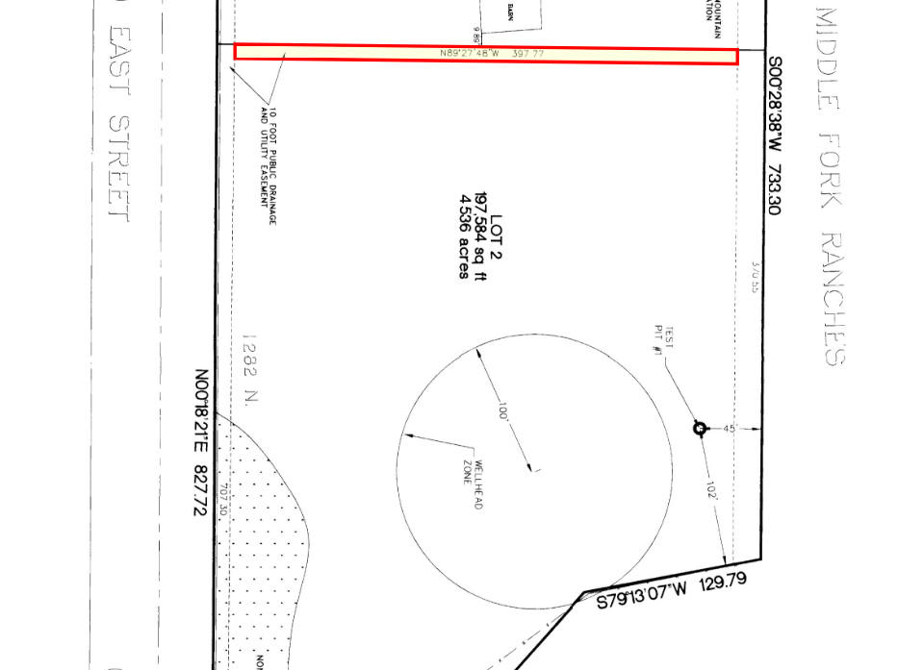

Dedication Plat 60-013